# Pop Culture Reference



The show follows the adventures of stepbrothers Phineas Flynn (Vincent Martella) and Ferb Fletcher (Thomas Sangster), who live in the fictional city of Danville, in a (never specified) Tri-State area, as they seek ways to occupy their time during their summer vacation. Often these adventures involve elaborate, life-sized and ostensibly dangerous construction projects. Phineas's older sister, Candace Flynn (Ashley Tisdale), has two obsessions: "busting" Phineas and Ferb's schemes and ideas, and winning the attention of a boy named Jeremy (Mitchel Musso).Meanwhile, the boys' pet platypus, Perry, acts as a secret agent for an all-animal government organization called the O.W.C.A. ("Organization Without a Cool Acronym"), fighting Dr. Heinz Doofenshmirtz.

# 2. Books

Platypus have shown up in a popular book series by Jarrett j krosoczka, The Platypus Police squad. 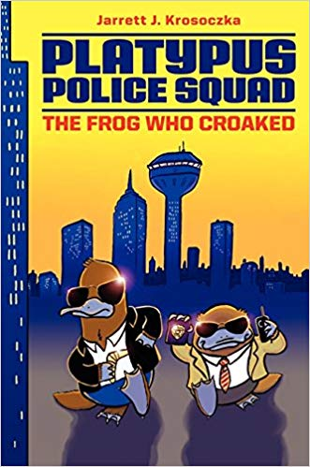

Home page